CMPE 283: Virtualization Technologies

## Assignment 3: Instrumentation via hypercall

### Bhavya Tetali (014535144), Supriya Meduri (015262767)

## Contribution of Team Members

Bhavya Tetali:

* Modified the code in vmx.c to track the exit types by exit reason.
* Modified the code in cpuid.c to support new LEAF node
* Created a user program to print count for all specific exit reasons.
* Created the documentation.

Supriya Meduri:

* Researched about exit types that are not defined by the SDM and not enabled in the KVM. And did the changes to cpuid.c to handle the exit types accordingly.
* Install cpuid package and researched about its usage.
* Created a user program to print count for a specific exit reason.
* Updated the documentation.

## Environment Setup :

We built this homework based on assignment-2 and hence followed the same environment setup.

## Modification of kernel code

Updated vmx.c to keep track of exit counts by exit reason. Updated cpuid.c to support new CPUID leaf 0x4FFFFFFE

In the outer VM, do the following:

* Remove the kvm and kvm_intel modules

|  |
| --- |
| $ sudo rmmod kvm_intel  $ sudo rmmod kvm |

* Compile the updated kernel code

|  |
| --- |
| $ sudo make -j 8 modules M=arch/x86/kvm |

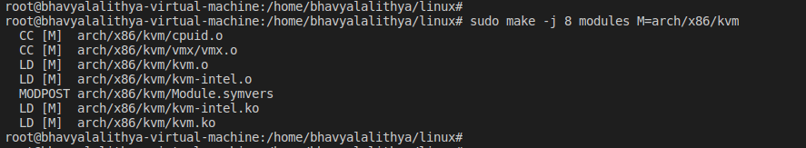

* Install the modules

|  |
| --- |
| $ sudo insmod arch/x86/kvm/kvm.ko  $ sudo insmod arch/x86/kvm/kvm-intel.ko |

* In inner VM, installed cpuid package
* In the terminal run the commands to test each leaf

|  |
| --- |
| $ cpuid -l 0x4ffffffd -s exit_number |

* In the outer VM , run the command “dmesg” to view the print statements

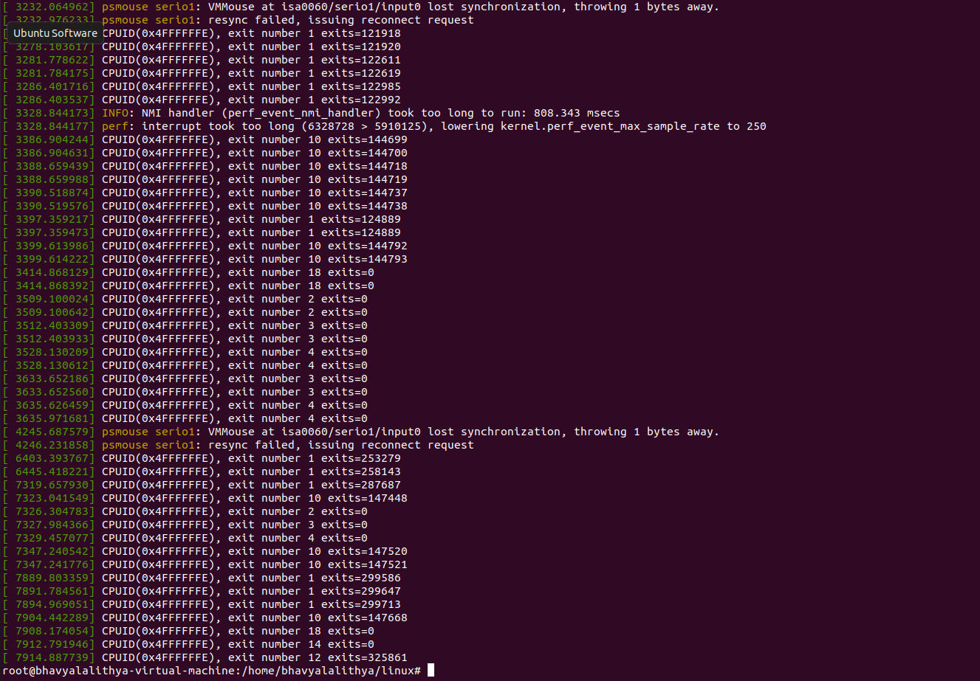

## Screenshots

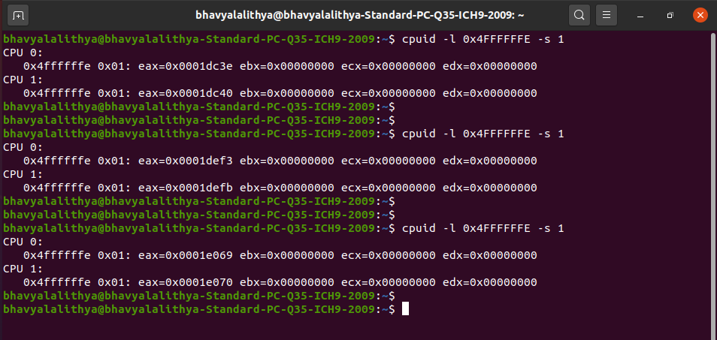

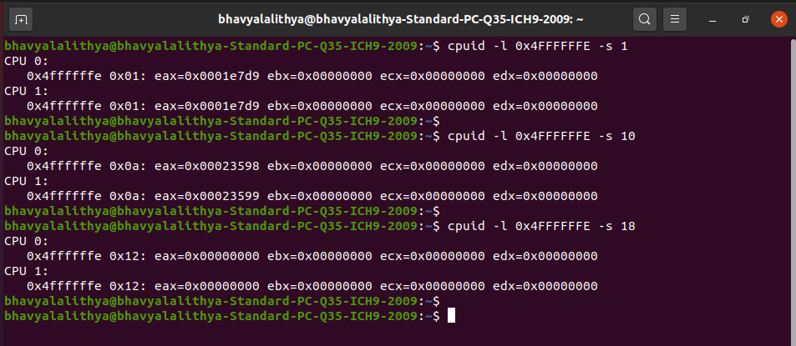

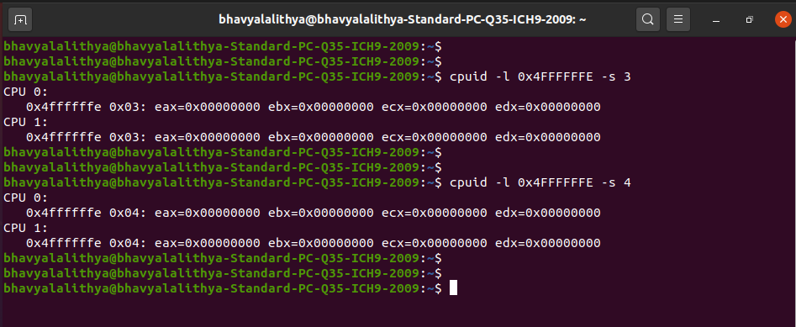

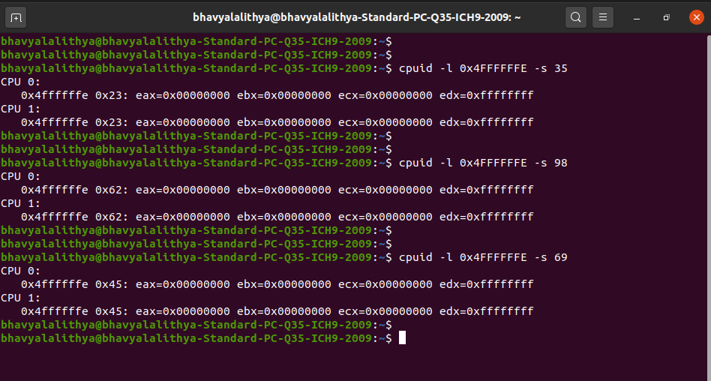

**Frequency of exits for exit 48**

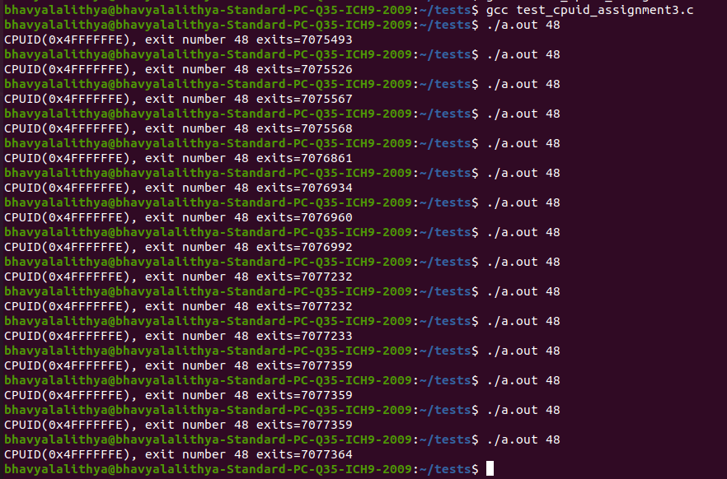

**Before boot**

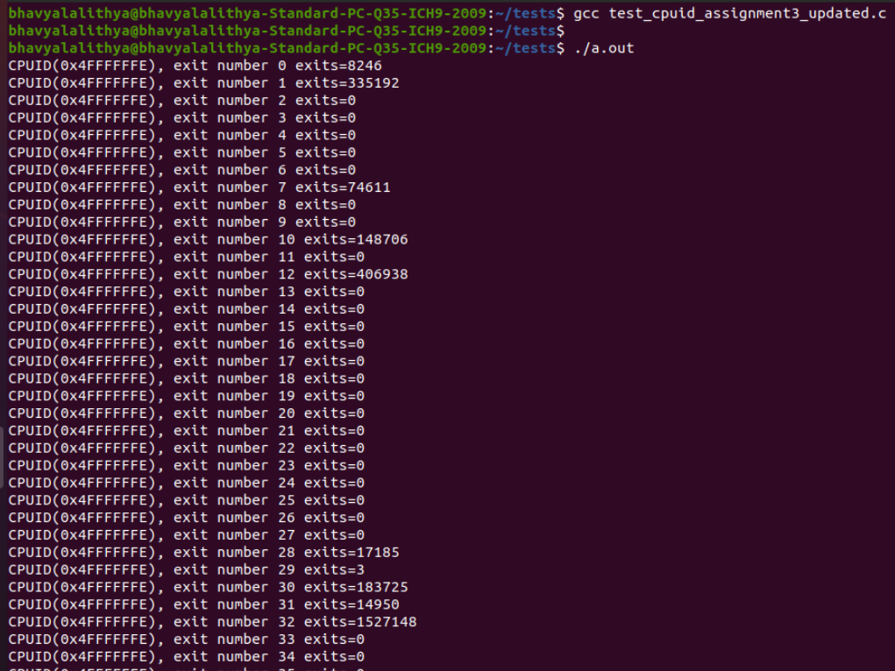

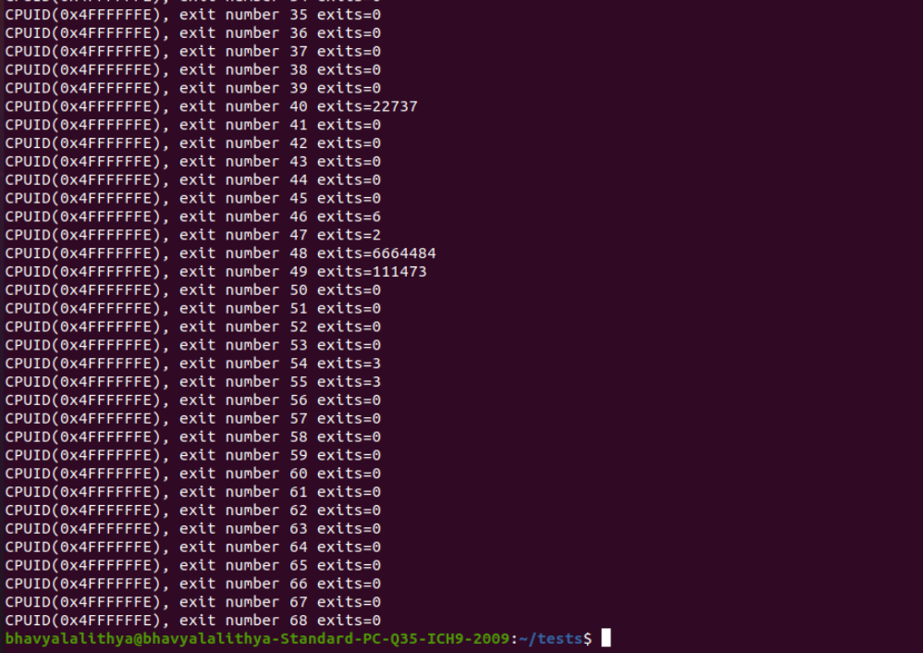

**After boot**

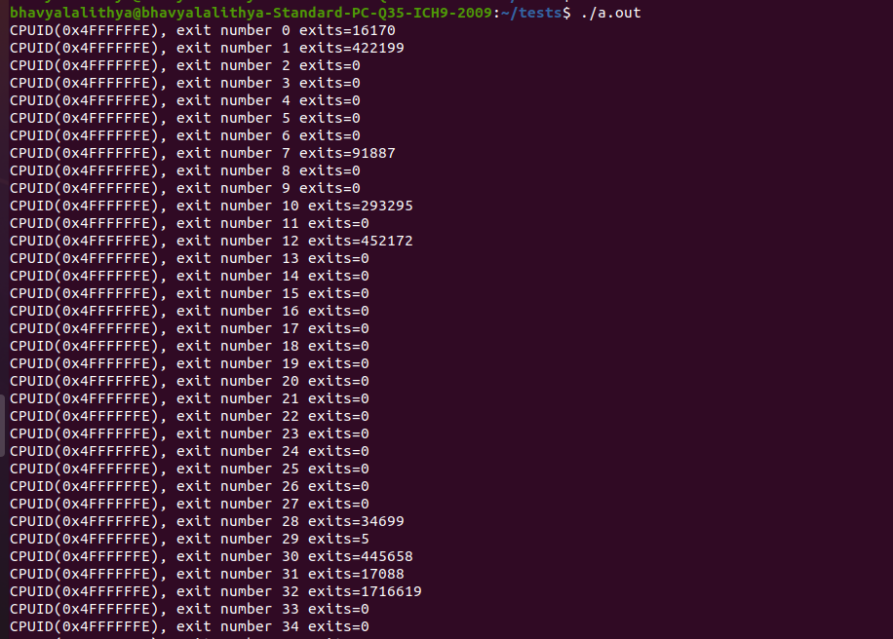

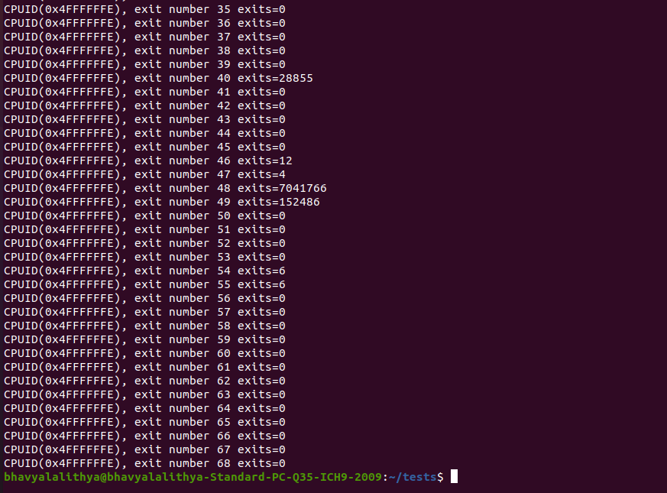

## Observations

**Q) Comment on the frequency of exits – does the number of exits increase at a stable rate? Or are there more exits performed during certain VM operations? Approximately how many exits does a full VM boot entail?**

**Ans** :- The frequency of exits is not increasing at a stable rate (as observed in the frequency of exits for exit 48 screenshot). From the above screenshots(before and after boot), we can observe that VM boot for exit 28 entails up to ~17k exits after full boot.

**Q) Of the exit types defined in the SDM, which are the most frequent? Least?**

**Ans :-** Most Frequent Exit:

* Exit number 48 - EPT Violation
* Exit number 32 - WRMSR
* Exit number 1- External Interrupt

Least Frequent Exit :

* Exit number 54 - WBINVD
* Exit number 55 - XSETBV
* Exit number 29 - MOV DR